

**YEAR: 7**

**2018**

**SUBJECT: Science**

**TEST: Observations, Inferences and Variables**

**TIME: 45 minutes**

**QUESTIONS: 15 Multiple Choice (15 marks)**

**8 Short Answer ( marks)**

**TOTAL MARKS: marks**

**DO NOT WRITE ON OR MARK THIS PAPER**

**SECTION ONE—MULTIPLE CHOICE** (10 marks)

This section has **10** questions. Answer **all** questions on the separate Multiple-choice Answer Sheet provided.

1. What equipment would measure the volume of a quantity of liquid most accurately?
2. Beaker
3. Test tube
4. Conical flask
5. Measuring cylinder
6. Which statement correctly describes the flame of a Bunsen burner with the **collar closed**?
7. Clean, hot and blue
8. Clean, hot and yellow
9. Smoky, cooler and blue
10. Smoky, cooler and yellow
11. Identify the equipment shown in the scientific drawing below:

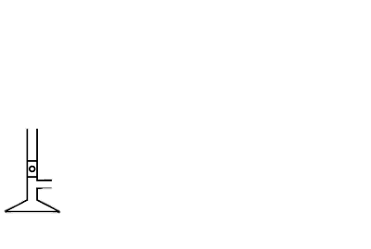

1. Retort stand
2. Measuring cylinder
3. Bunsen burner
4. Beaker
5. 4. When heating a test-tube, you should point it away from everyone, including yourself. Which is
6. the best reason for this rule?

a) It’s easier to see what’s going on in the test-tube.

b) Hot liquid can spit out and hit people.

c) To stop people seeing what you are doing.

d) This way, the liquid is less likely to spit out.

5. Which of the options below is the **most accurate** measurement as shown in the diagram of a

measuring cylinder?

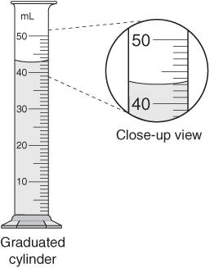

a) 41 mL

b) 42 mL

c) 43mL

d) 44mL

6. Which of the following observations are **quantitative**?

1. The candle has a greasy feel.
2. The rubbish bin has a strong odour.
3. The temperature of the water was measured at 37°C.
4. The soup is so hot that it hurts my teeth.

7. Which of the following is ***not*** a metric unit of measurement?

a) litre

b) kilometre

c) inch

d) gram

**For questions 8, 9 and 10 read the information below:**

A scientist was trying to see if the amount of water a plant gets affects plant growth. She collected 10 identical plants and gave them different amounts of water. She measured their growth daily. The plants received the same amount of sunlight.

8. What is the **independent** variable?

a) plant growth.

b) amount of sunlight.

c) amount of water.

d) 10 plants.

9. What is the **dependent** variable?

a) amount of sunlight

b) plant growth

c) growth measured daily

d) none of the above

10. What are the **controlled** variable(s)?

a) amount of sunlight

b) 10 identical plants

c) amount of water

d) both A and B

1. 11. Eddie notices that his Bunsen burner is making a hissing noise. The most sensible action he should take immediately is to:

a) tell his teacher.

b) run for the door.

c) blow out the flame.

d) turn off the gas at the gas tap.

12. Choose the option that shows the correct order to light the Bunsen burner:

1. Open air hole, light match, turn on gas.
2. Close air hole, turn on gas, light match.
3. Close air hole, light match, turn on gas.
4. Open air hole, turn on gas, light match.

13. The flame of the Bunsen burner should be extinguished by:

1. slowly opening the air hole.
2. closing the air hole.
3. blowing it out.
4. turning off the gas tap.

14. Your friends return from a canoe trip on a lake and they are dripping wet. What **inference** might you make?

1. Their clothes are wet.
2. They are tired.
3. Their canoe tipped over.
4. They are really good at canoeing.

15) A chart showing the amount of rain collected each month in a certain region is a scientist’s

a) variable

b) inference

c) data

d) conclusion

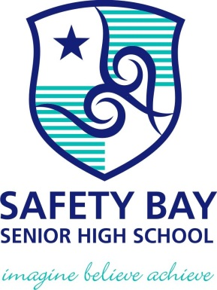

**SEMESTER ONE 2018**

**Transition Science Test:**

**ANSWER BOOKLET**

**NAME:**

**FORM:** **DATE:**

Multiple Choice Short Answer Total

**/**

**/15**

**/**

**SECTION ONE:** Multiple choice answers

Cross (X) through the correct answer.

|  |  |  |  |  |
| --- | --- | --- | --- | --- |
| **1** | a | b | c | d |
| **2** | a | b | c | d |
| **3** | a | b | c | d |
| **4** | a | b | c | d |
| **5** | a | b | c | d |
| **6** | a | b | c | d |
| **7** | a | b | c | d |
| **8** | a | b | c | d |
| **9** | a | b | c | d |
| **10** | a | b | c | d |
| **11** | a | b | c | d |
| **12** | a | b | c | d |
| **13** | a | b | c | d |
| **14** | a | b | c | d |
| **15** | a | b | c | d |

**SECTION TWO: Short Answer ( marks)**

Answer the questions in the spaces provided.

1. Write two items that all students must use in the Science Laboratory to keep them safe, and how these items help to protect the students: (6 marks)

|  |  |
| --- | --- |
| **Item Name** | **How the item protects the student** |
|  |  |
|  |  |

1. State **two** metric units commonly used to measure: (6 marks)
   1. Distance
   2. Volume
   3. Mass
2. You are using a Bunsen burner to heat water in a beaker. Draw a **scientific diagram** to show how your equipment looks. You must use **proper 2D diagrams** and **label** all pieces of equipment. (8 marks)
3. Next to each piece of equipment, write the measurement. Remember to include correct units. (3 marks)

A: The measurement on the ruler is: _______________________

1. 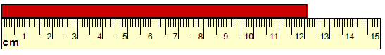

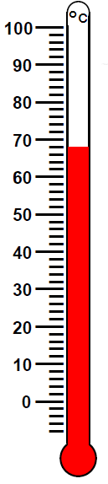

C: The temperature

shown on the

thermometer is:

_________________

B: The volume of liquid in the cylinder

is: ________________

1. 

5.Label the following statements as **observations** or **inferences**: (6 marks)

1. The liquid in the beaker is water
2. Steam is rising from the soup
3. The liquid in the beaker is colourless
4. The cat is meowing loudly
5. The soup is hot
6. The cat is hungry
7. Sarah and Jake want to find out how the volume of water in a cup affects how fast an Aspro-clear tablet will dissolve. They get four cups:

Cup 1: 20mL water

Cup 2: 40mL water

Cup 3: 60mL water

Cup 4: 80mL water

1. What is the independent variable?

_________________________________________________________________________________

1. What is the dependent variable?

_________________________________________________________________________________

1. List THREE controlled variables that Sarah and Jake would need to keep the same:

_________________________________________________________________________________

_________________________________________________________________________________

_________________________________________________________________________________

1. Write a suitable hypothesis for Sarah and Jake’s experiment:

______________________________________________________________________________

1. What is the difference between *qualitative* and *quantitative* observations? Explain each one with the help of an example. (5 marks)

1. What is the difference between a mistake and an error? Explain each with the help of an example.

**END OF TEST**